

**SOFTWARE DESIGN**

**SECTION 01A**

**SRS**

**Group Members:**

| **No.** | **Name** | **Matric ID** |
| --- | --- | --- |
| 1 | OTHMAN ABDULAZIZ | CB22022 |

Use Case Diagram:  
  
  
  
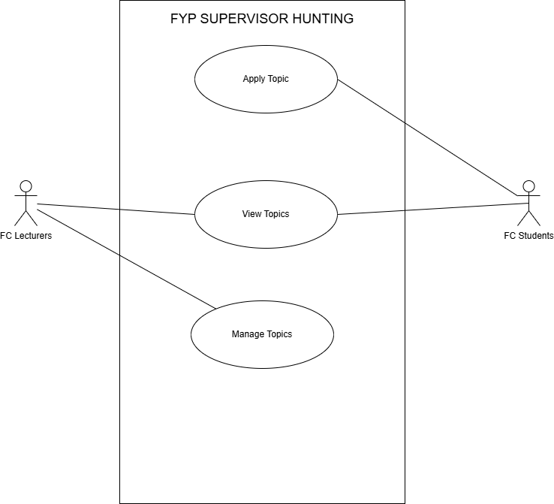

Use Case Discription:

| **Use Case ID** | **UC001** |
| --- | --- |
| **Feature** | FYP Topic Application |
| **Purpose** | Allow students to view, select, and apply for FYP topics posted by lecturers. |
| **Actor(s)** | FC Students, FC Lecturers |
| **Preconditions** | 1. FC Lecturers have posted available FYP topics.  2. Students and lecturers are logged into the system.  3. System displays a list of available topics. |
| **Main Flow** | 1. **FC Student** views the list of available topics. 2. **FC Student** selects a topic and clicks **"Apply"**. **(Refer to E1 if the topic is already taken).** 3. **System** updates the topic status to **"Pending"** and notifies the respective lecturer. 4. **FC Lecturer** views the application and either: a) Accepts the topic. b) Rejects the application **(Refer to E2 if rejected).** 5. **System** updates the topic status and sends a notification to the student. 6. If **Accepted**, the **System** updates the lecturer’s quota automatically. **(Refer to E3 if lecturer’s quota is full).** |
| **Exception Flows** | E1: Topic Already Taken  - The system prevents the student from applying for a topic that is already accepted.  - System displays: "This topic is no longer available. Please choose another topic."  E2: Lecturer Rejects Application  - System updates the topic status to "Rejected".  - System notifies the student of the lecturer’s decision.  E3: Quota Full  - System prevents further applications when the lecturer's quota is full.  - System displays: "Lecturer quota is full. Please select another lecturer or topic." |

Sequence Diagram:  
  
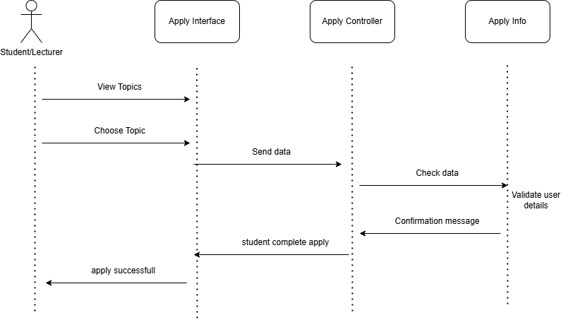

**Exception Flows 1:  
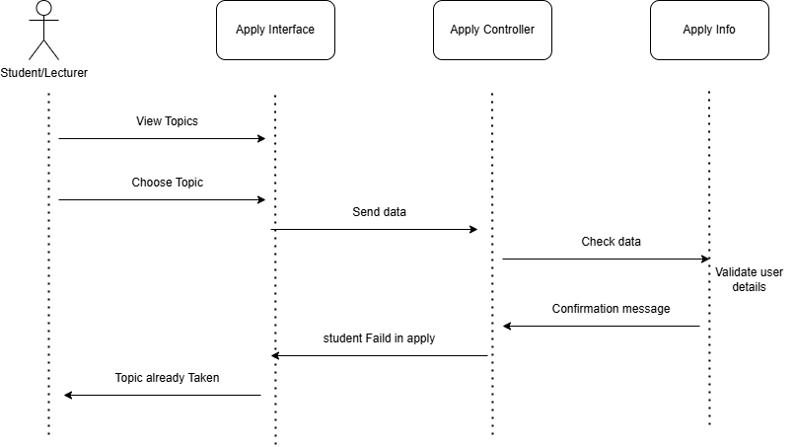**

**Exception Flows 2:  
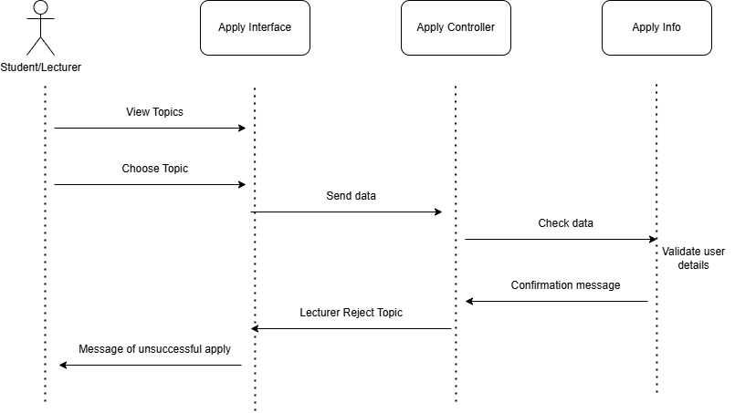  
  
  
Exception Flows 3:  
  
